< 김대균의 Tycoon 토익 첫걸음 – Lesson 2 >

[PART 1] 8개의 이야기

1. 움직이는 사람들

1.
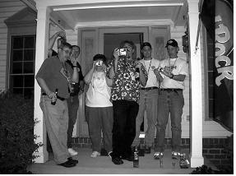
2.


2. 어떻게 생겼나?

1.
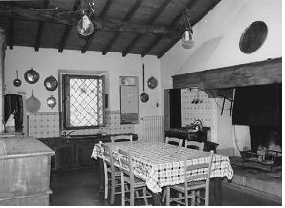
2.


3. 점점 길어지는 이야기

1.
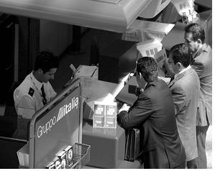

2.

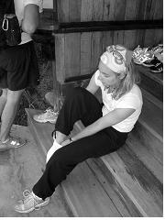

4. 누가 그랬는지는 몰라요

1.

2.


5. 왜 이걸 몰랐을까?
1.

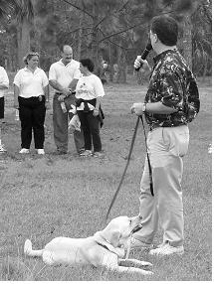
2.


[PART 5&6] 준비되셨나요? p.191~195

1. The tape recorder has a SPEED button that provides the user with ------- over the tempo at which the song is played.
(A) controlling
(B) control
(C) to control
(D) controlled

2. New playground equipment with improved safety features has been installed in ------- of the old and damaged swing set.
(A) placing
(B) placed
(C) place
(D) to place

3.The judge was in complete ------- with the mother in this case, and ruled that the child should not be sent to its grandparents.
(A) agreed
(B) agree
(C) agreement
(D) agreeing

4. ------- in emergencies can be obtained from organizations such as the Red Cross, the United Nations, or the Salvation Army.
(A) Assist
(B) Assistance
(C) Assists
(D) Assistant

5. The Tal-Mart Furniture Store offers a ------- of quality home furnishings including chairs, sofas, beds and tables.
(A) vary
(B) variety
(C) various
(D) varied

6. Many things should be considered by employees before making a relocation -------.
(A) decision
(B) decider
(C) decide
(D) deciding

7. Our company has issued a policy that states (that) every ------- must have an annual performance evaluation.
(A) employee
(B) employment
(C) employs
(D) employ

8. Now that he has graduated, he is interested in applying for a ------- in psychology at a small hospital in New Jersey.
(A) positioning
(B) position
(C) positioned
(D) positions

9. I have found that the librarian was quite helpful in ------- documents in the files or even on the Internet.
(A) locating
(B) located
(C) will locate
(D) to locate

10. Every decision about ------- a business alliance needs to consider the benefits of the new partnership as well as its limitations.
(A) to join
(B) join
(C) joining
(D) joined

< 정답 >

1. B
2. C
3. C
4. B
5. B
6. A
7. A
8. B
9. A
10. C

TOEIC VOCABULARY for Kim Dae Kyun's Students
relinquish * To give up your power , position, or an advantage especially when you do
not want to do this 포기하다
ex) She was forced to relinquish her leadership.

expertise 전문지식
* Special skill or knowledge that you get from experience, training or study
ex) Technical professional medical expertise.

initiative 독창성
* The ability to decide in an independent way
what to do and when to do it
ex) Mr. Hills showed initiative and bravery when dealing with a dangerous situation.

slash 삭감하다
* Mainly journalism to reduce something by a large mount
ex) Congress voted to slash funds for several domestic programs.

authorization 허가
* Official permission to do something
ex) The action was taken without the authorization of the leadership.

saturation 포화상태
* a situation in which something is so full of a particular type of thing that nothing more can be added
ex) indications that the market has reached saturation

landed 얻은 획득한
* including or relating to a large area of land with one owner
ex) a landed state

certificate 자격증
* An official document or record stating that particular facts are true
for example a birth certificate gives the official facts about your birth and a health certificate gives the facts about your state of health

afford 감당하다
* If you can afford something you have enough money to be able to pay for it
This word always follows “can” or ”could”
ex) We need a bigger house but we just can’t afford the rent.

dilapidated 황폐한
* A dilapidated building, vehicle, or system is old and in bad condition

